HEALTHY CHILDREN LEARN BETTER
Unicoi County Schools Office of Coordinated School Health is dedicated to improving the overall health of our students to make sure that our children are healthy and ready to learn. Our mission statement is to assure academic and personal success for each child. The Coordinated School Health model helps us to break down barriers to learning that children might have and to promote healthy habits for a lifetime! We hope you enjoy the links and information listed on our site.

Tennessee Department of Education Coordinated School Health

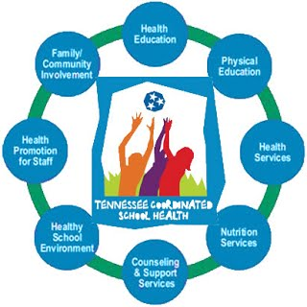

REGINA HARRELL TERESA SCOTT
SCHOOL HEALTH COORDINATOR ASSISTANT COORDINATOR
harrellr@unicoischools.com scottt@unicoischools.com
(423) 743-7820 (423) 743-1626
Vaccine Information
Flu and Men

Useful Website links
CDC’s BMI Calculator for Children and Teens
https://www.cdc.gov/healthyweight/assessing/bmi/index.html

TN Suicide Prevention Networks
http://tspn.org/

Bullying
https://www.stopbullying.gov/

USDA Choose My Plate
https://www.choosemyplate.gov/

Tennessee Office of Coordinated School Health
https://www.tn.gov/education/health-and-safety/coordinated-school-health.html

Healthier Tennessee Small Starts
https://healthiertn.com/streaks_for_small_starts

KidCentral TN
https://www.kidcentraltn.com/category/education

